**IBM NAAN MUDHALVAN**

**DOMAIN – DATA ANALYTICS WITH COGNOS**

**PHASE4- DEVELOPMENT PART2**

|  |  |
| --- | --- |
| **DATE** | 26.10.2023 |
| **TEAM ID** | PROJ_224694_TEAM_2 |
| **PROJECT TITLE** | CUSTOMER CHURN PREDICTION-TELECOMMUNICATION CUSTOMER CHURN PREDICTION |

**PROBLEM STATEMENT:**

To predict the customers who are likely to churn in the telecom industry.

**DATA VISUALIZATION USING IBM COGNOS ANALYTICS:**

**Step1:** Upload the dataset.

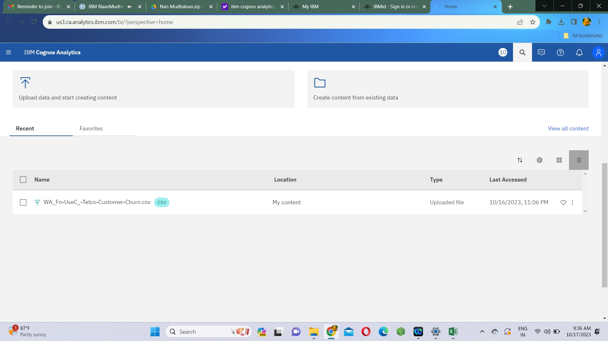

**Step2:** Create and save data module as Customer churn module.

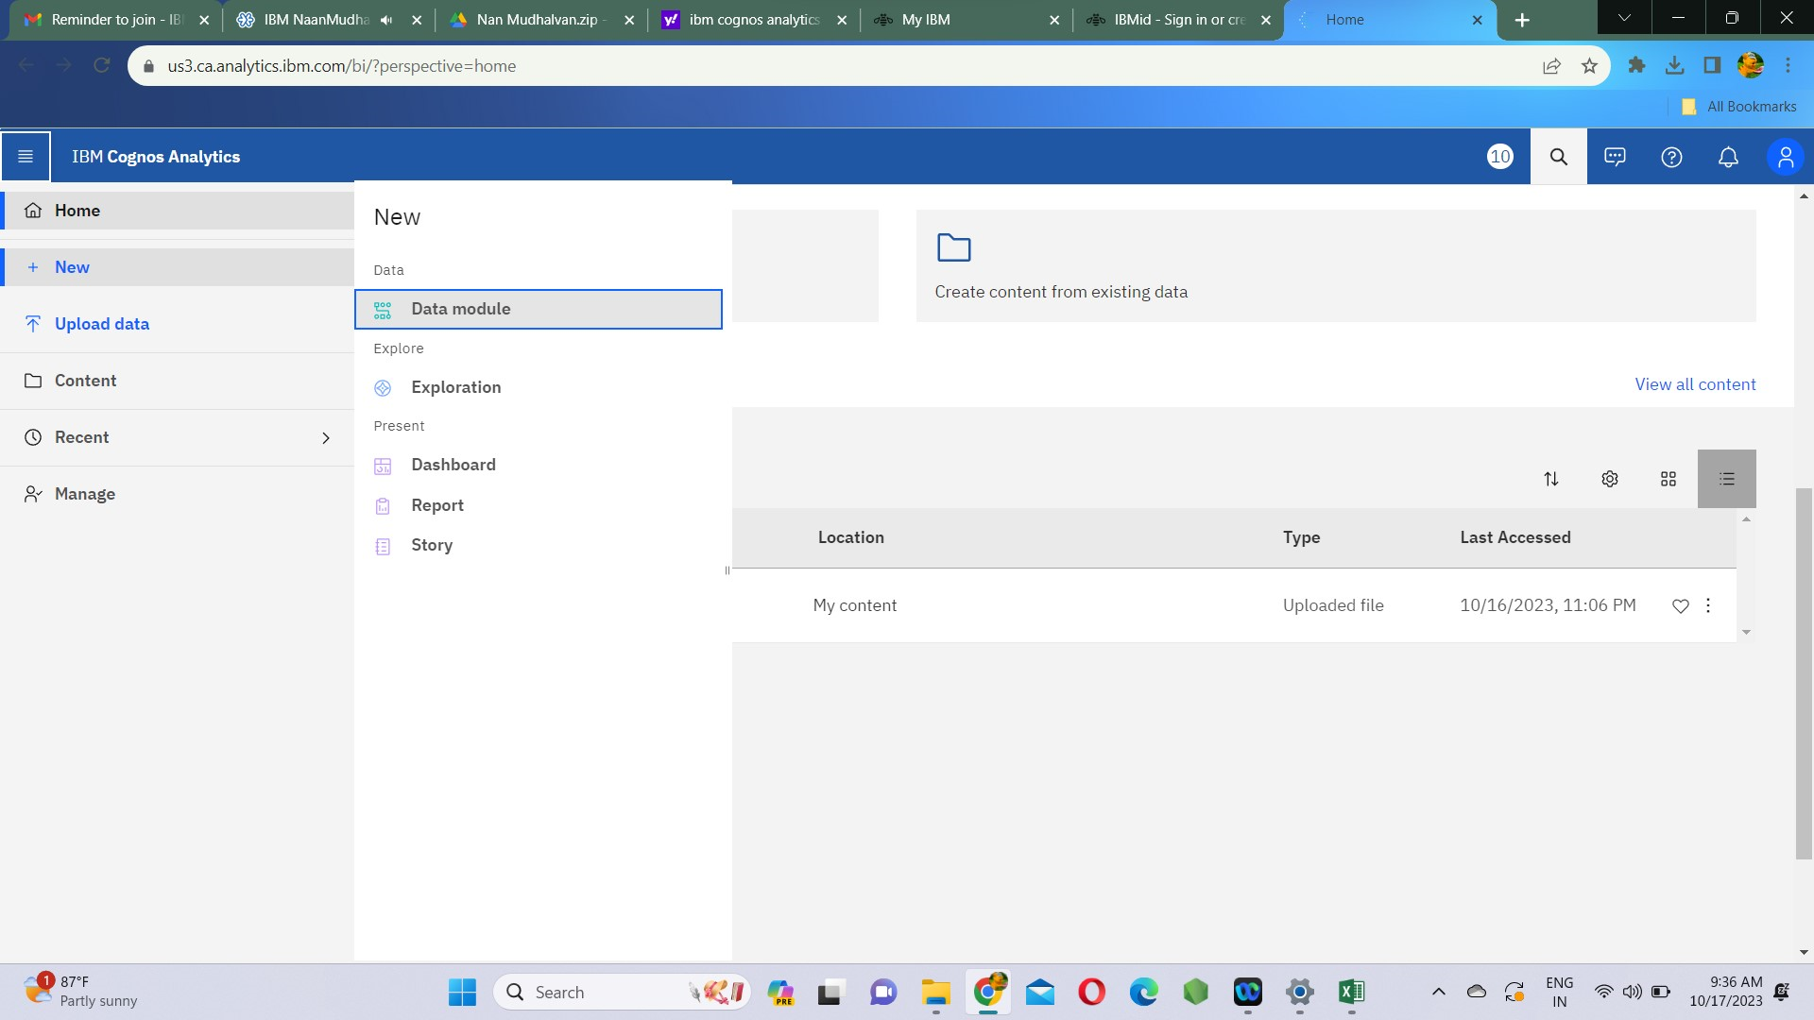

**Step3:** Also create a report in which we make the data visualizations.

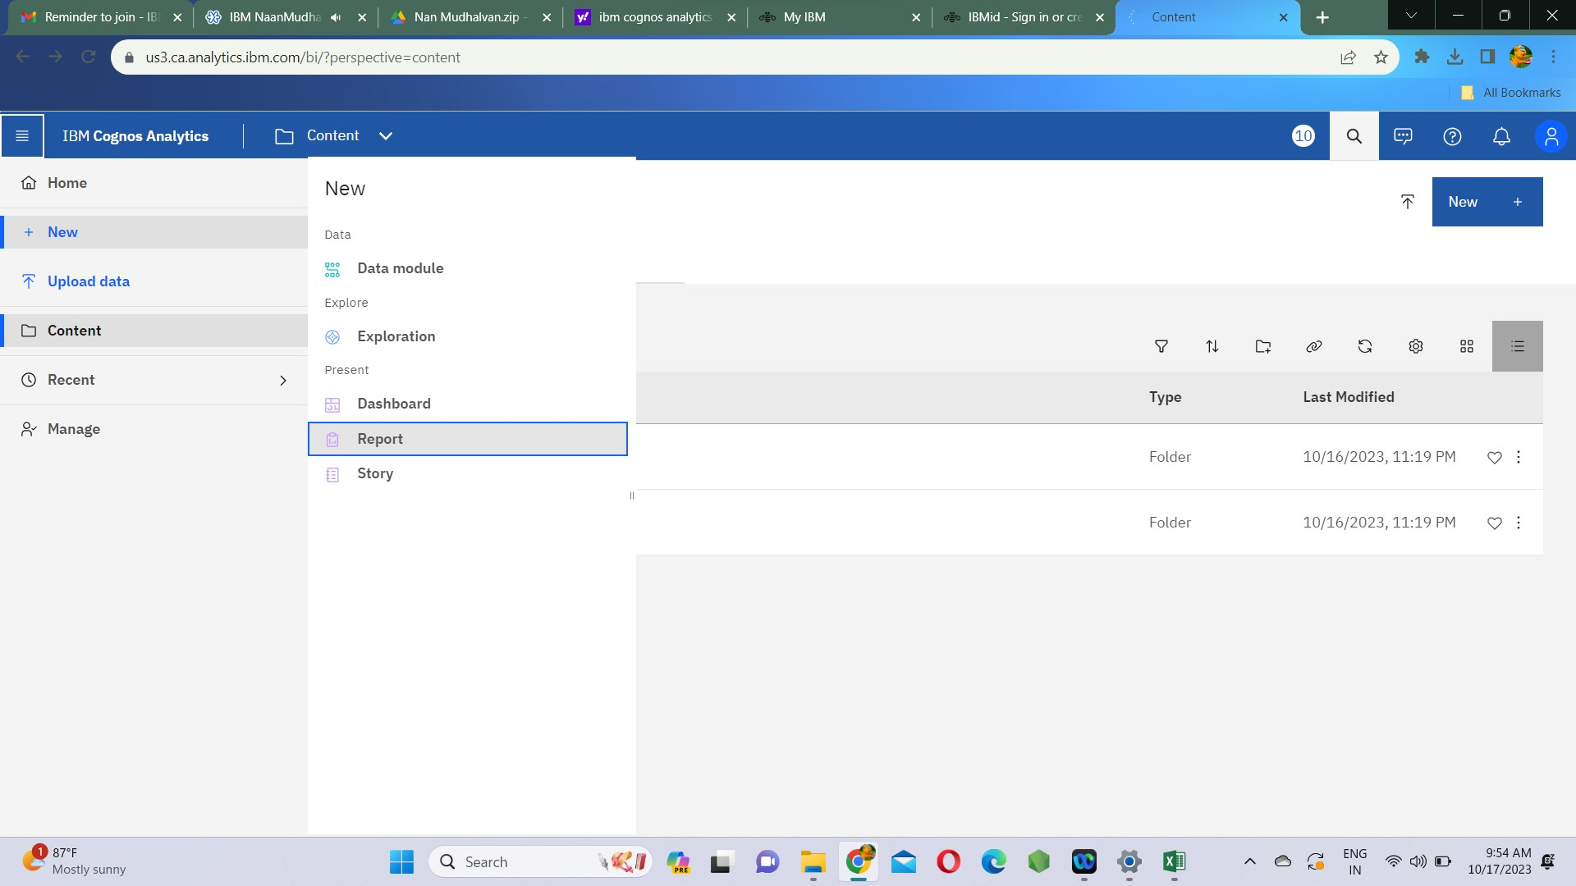

**Step4:** Select the csv source file for data visualization in report by clicking on select source. Also select templates and themes of the report.

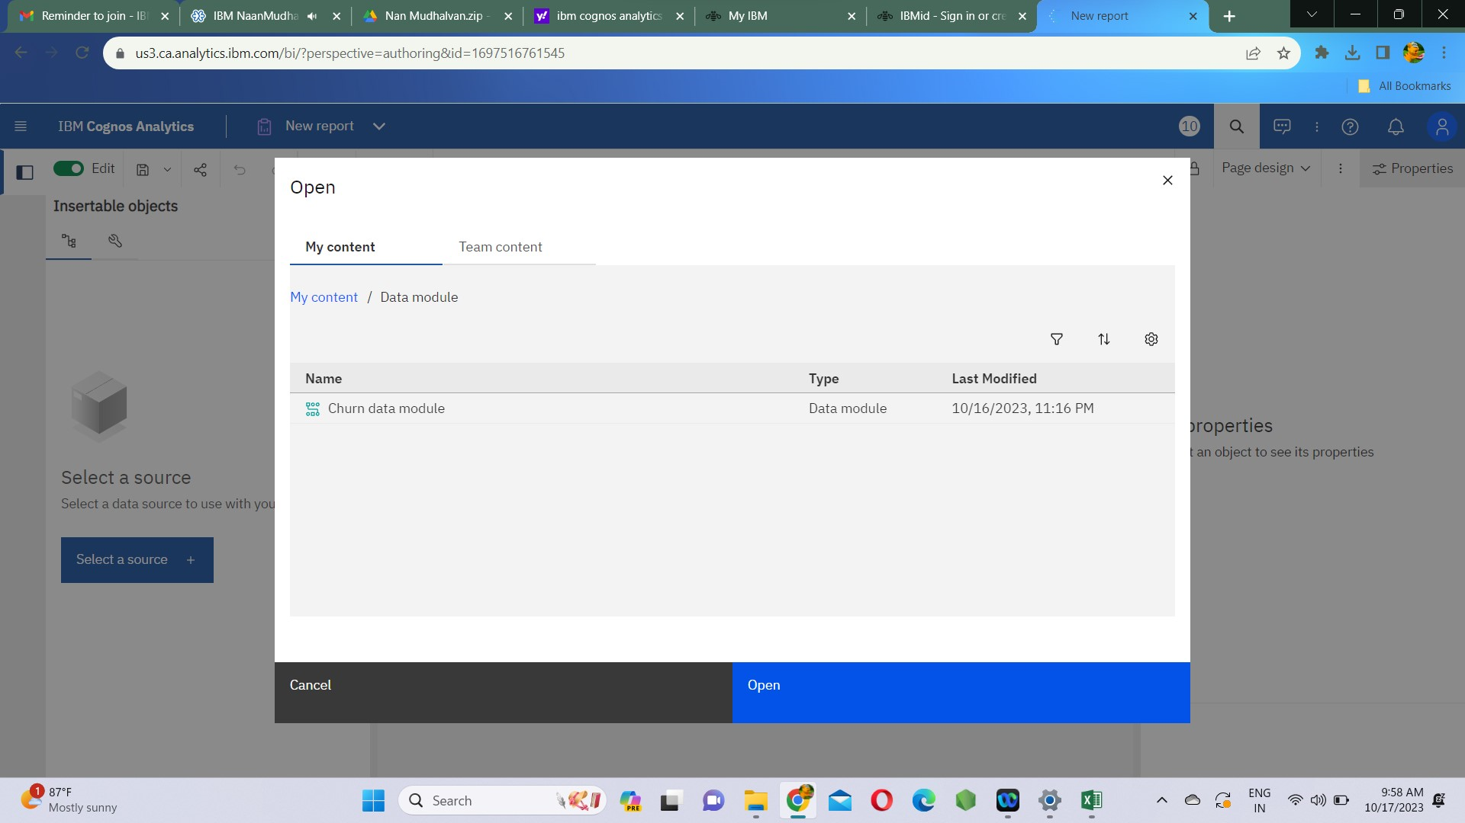

**Step5:** Select visualization under the select widget type.

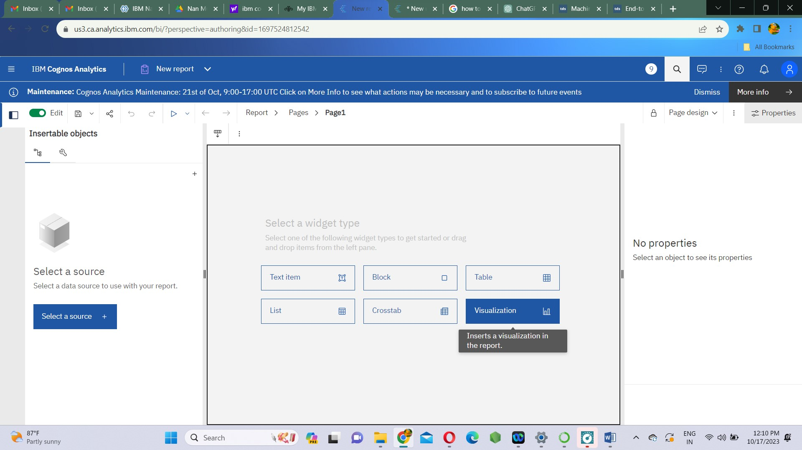

**Visualizations:**

We visualize the data in the form of bar plots and stack plots. By this we can understand the relation between various features of the dataset .

1. **Churn Vs Churn(count)**

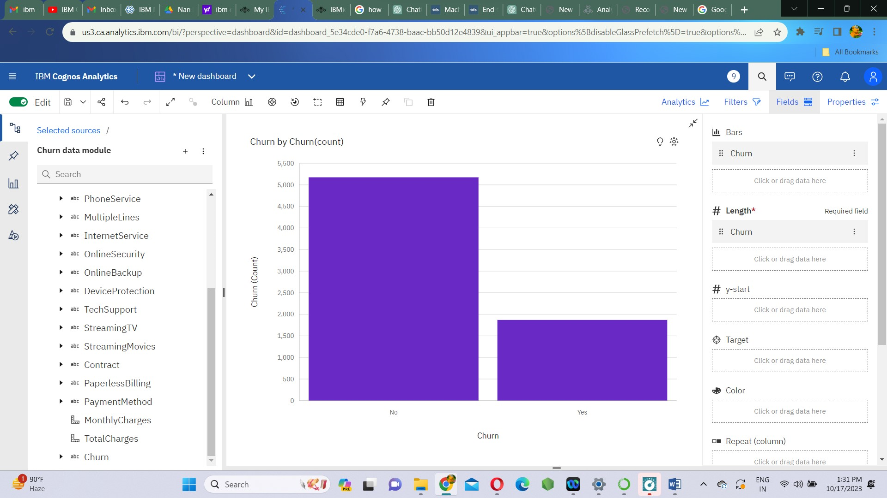

1. **Contract Vs Churn(count)**

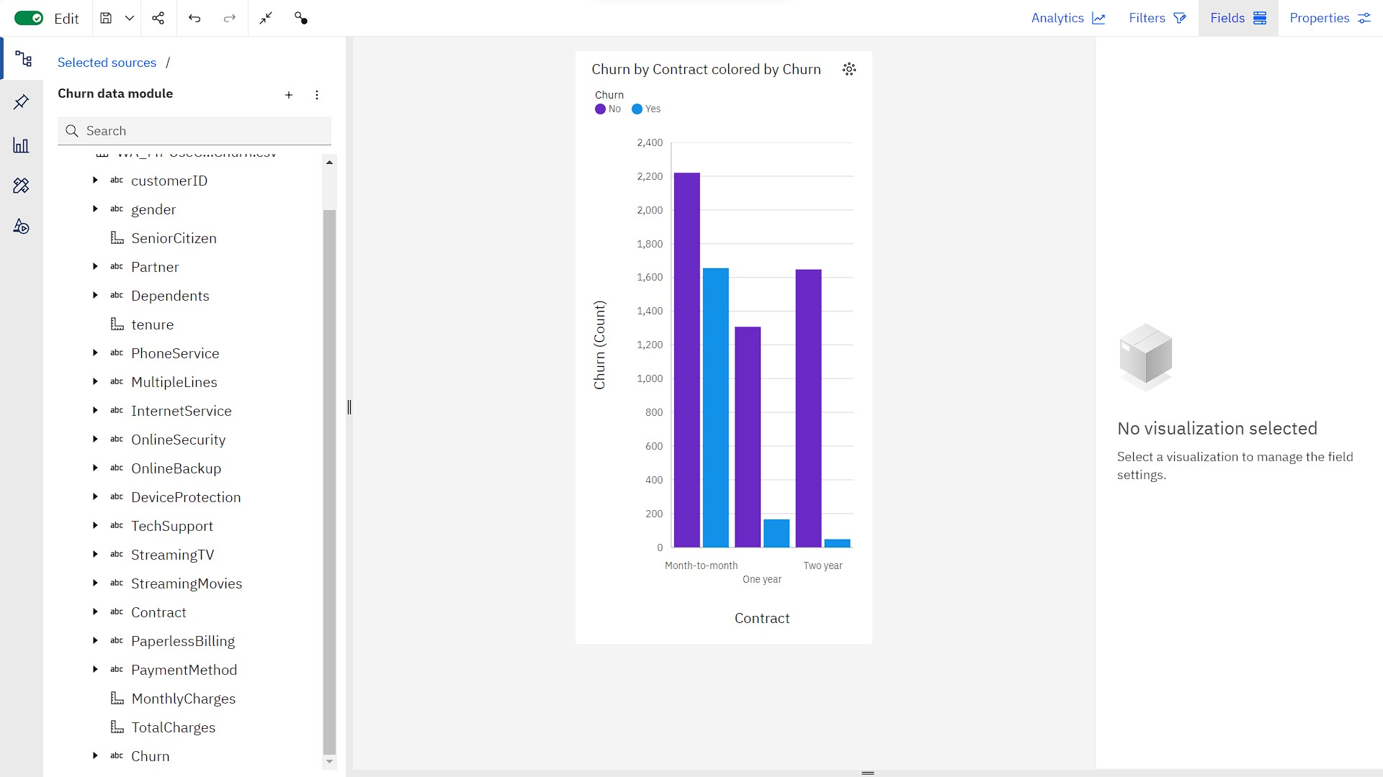

1. **SeniorCitizen Vs Churn(count)**

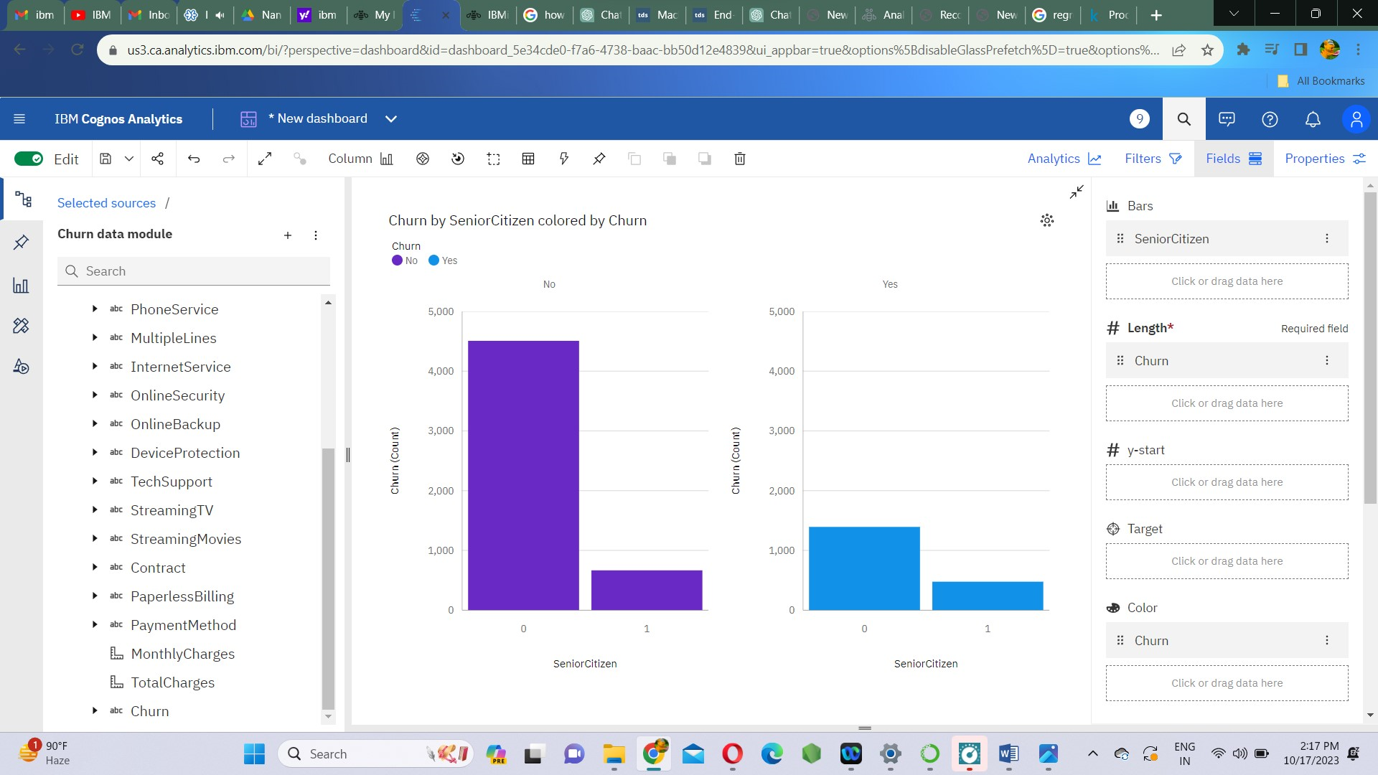

1. **gender Vs Churn(count)**

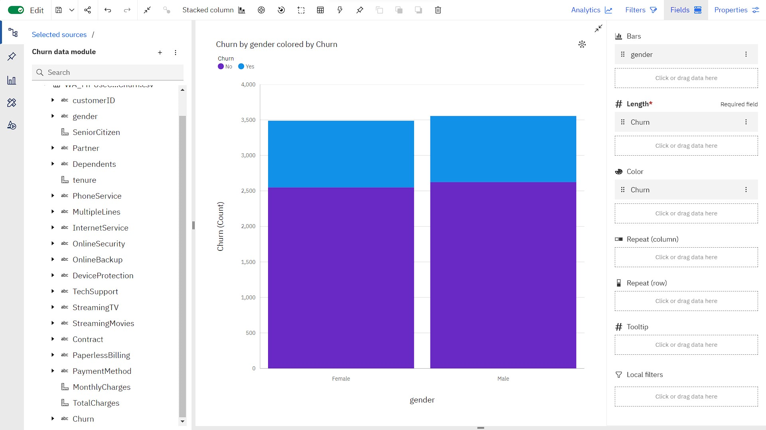

**FEATURE ENGINEERING**:

**Feature engineering** is the process of **extracting features from the data and transforming them into a format that is suitable for the machine learning model.**

**Label Encoding**

Label encoding is used to replace categorical values with numerical values. This encoding replaces every category with a numerical label.

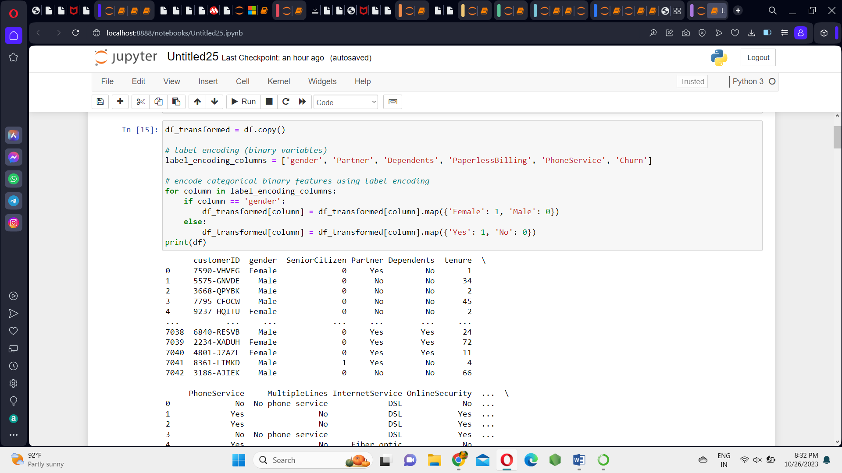

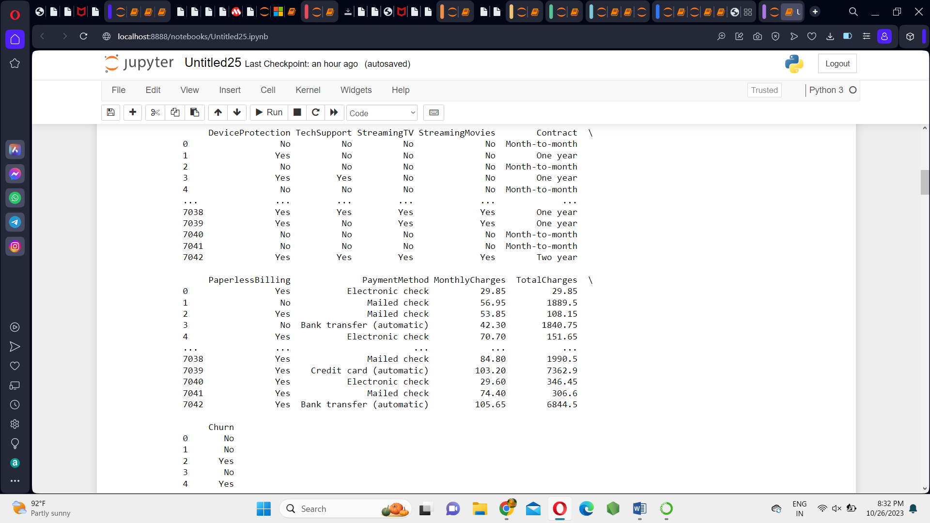

## One-Hot Encoding

**One-hot encoding** creates**a new binary column for each level of the categorical variable.** The new column contains zeros and ones indicating the absence or presence of the category in the data.

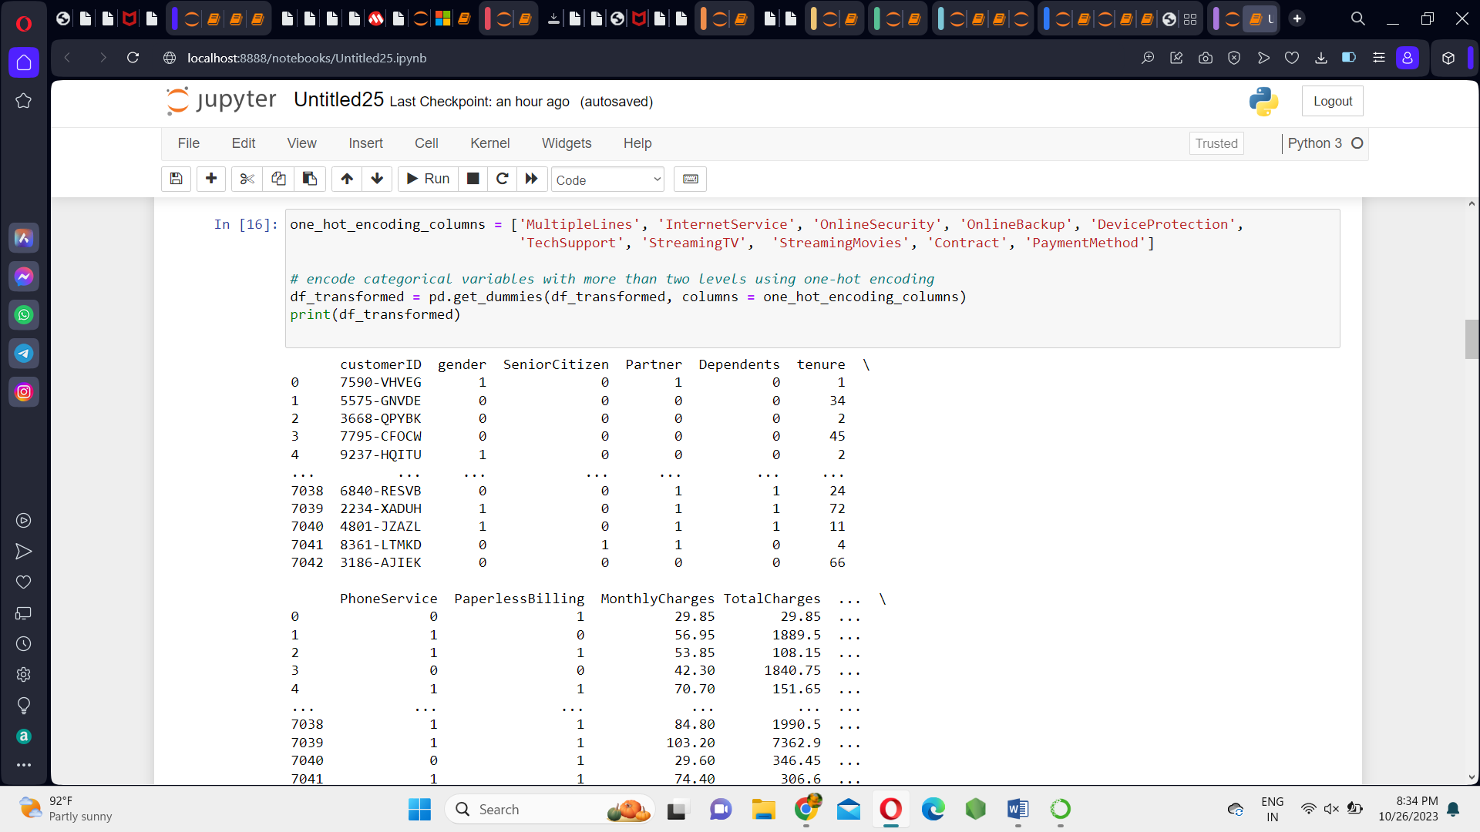

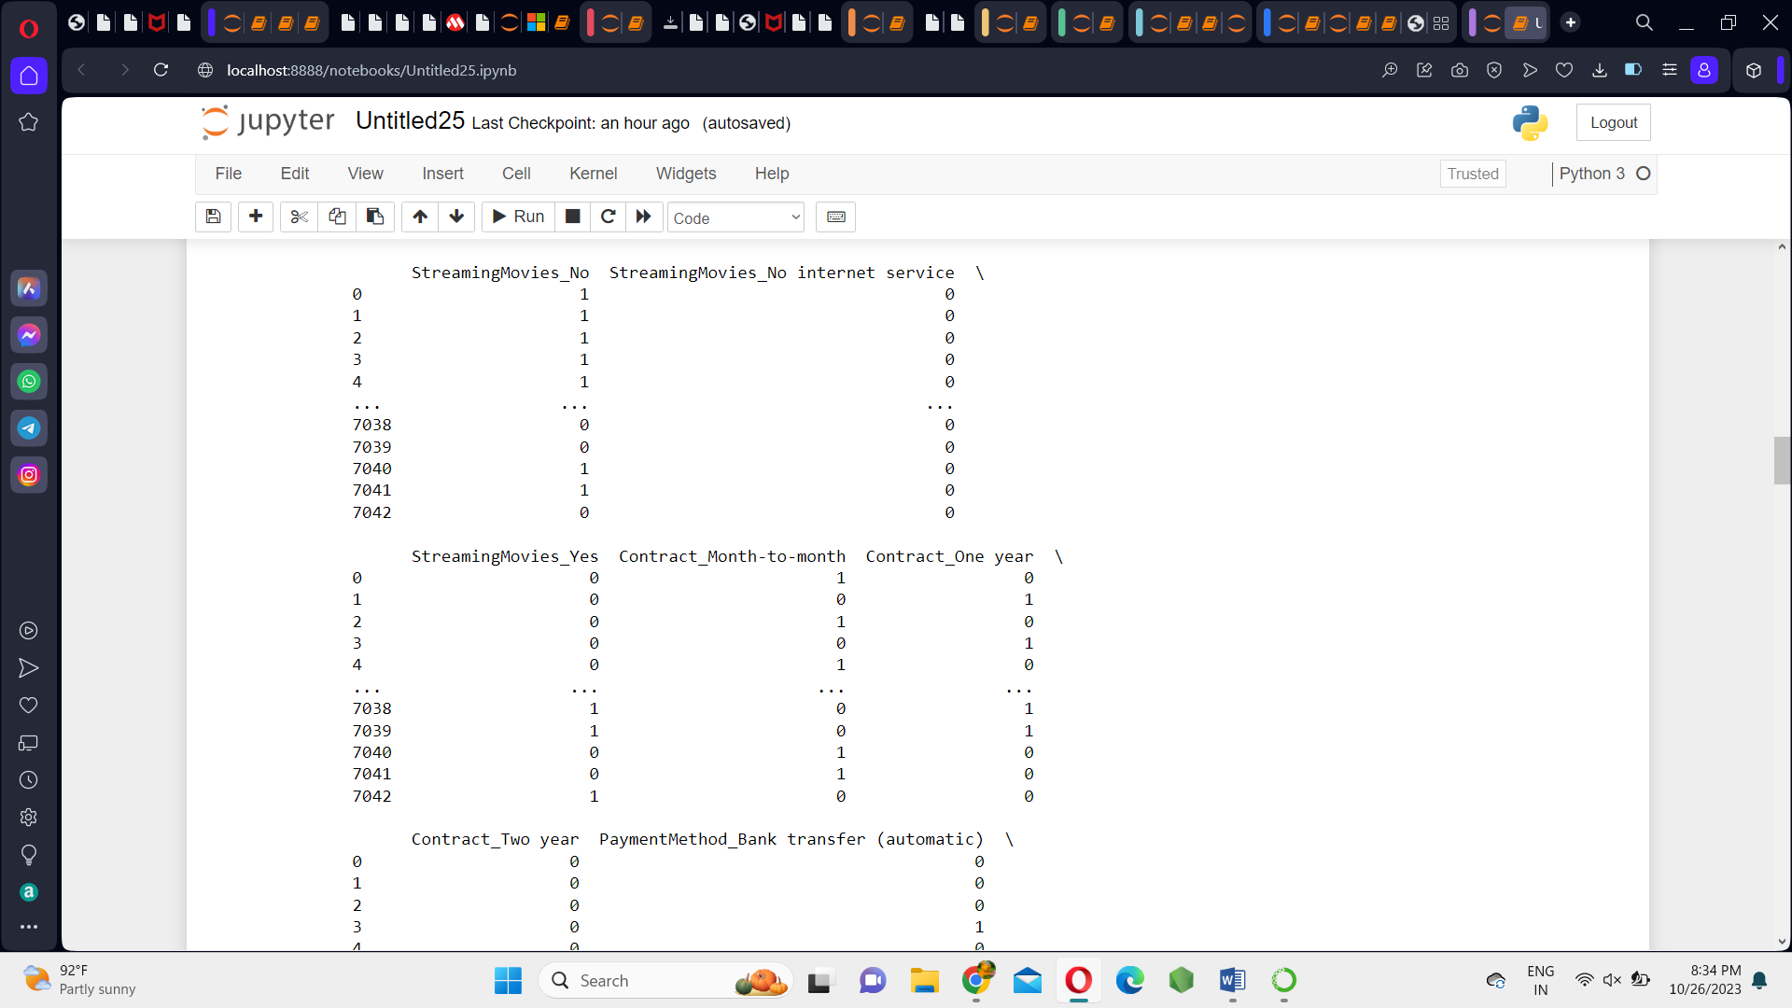

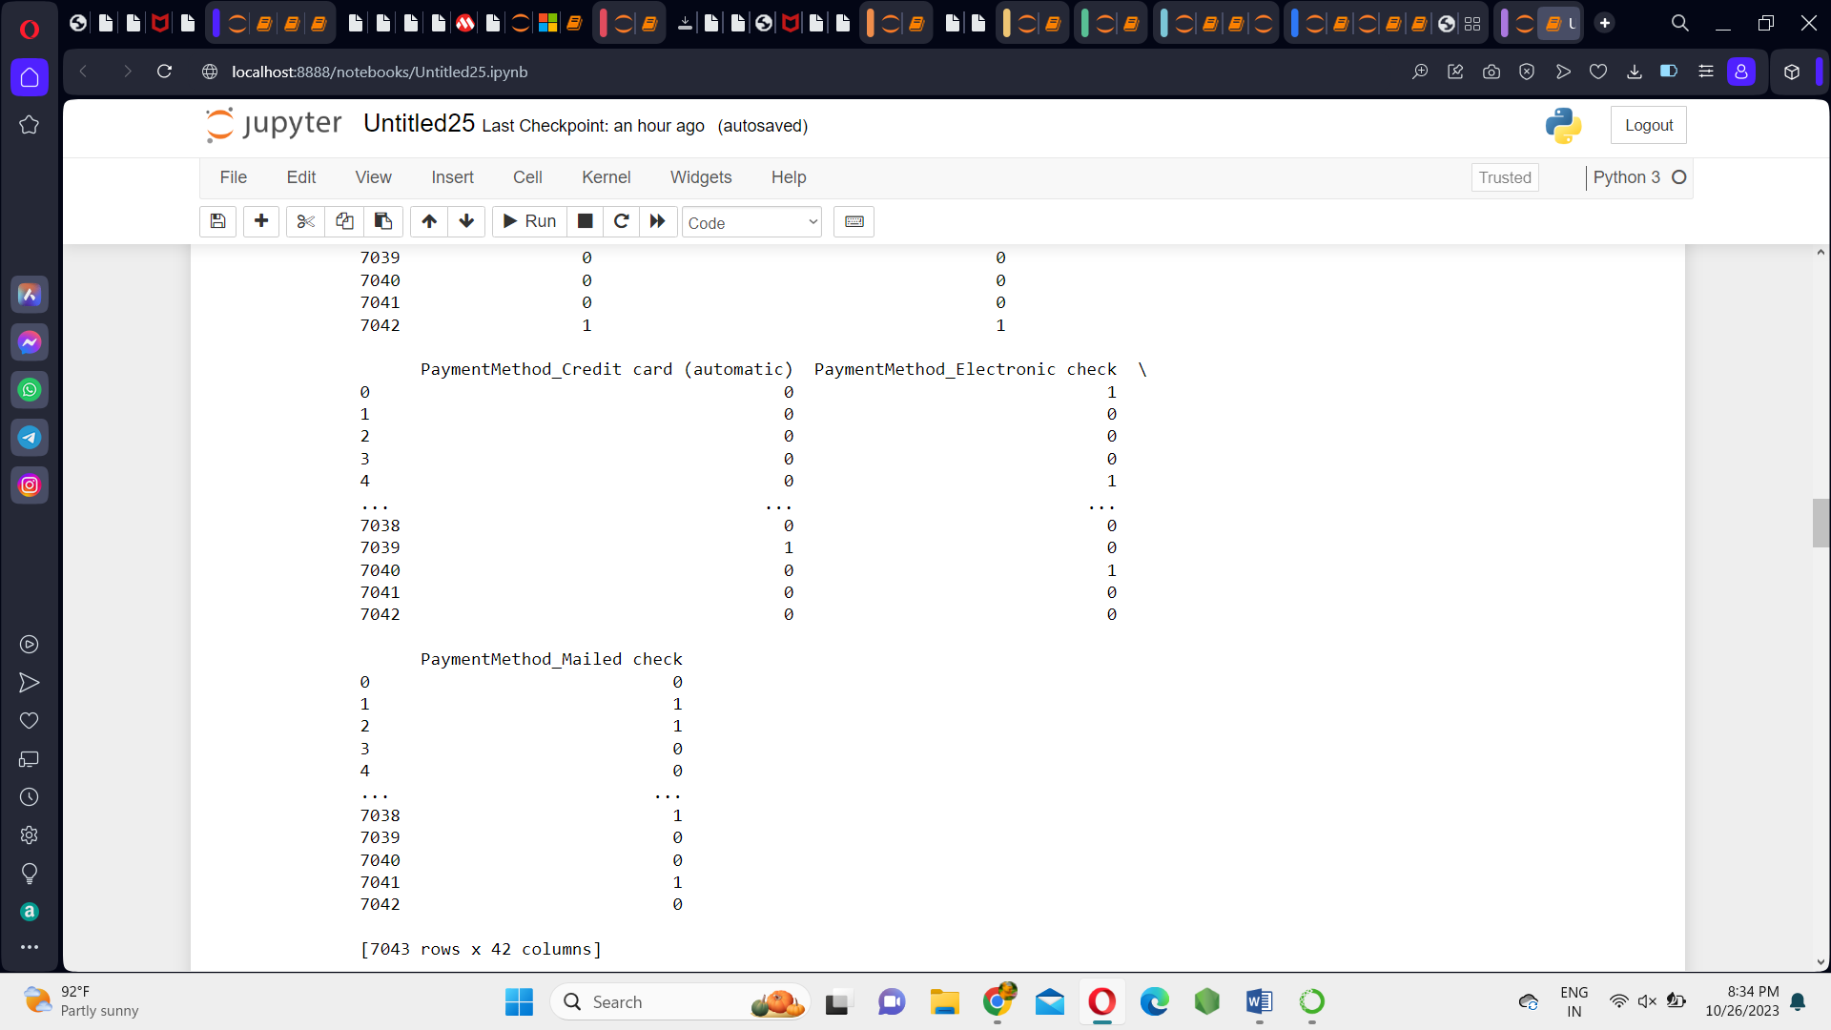

**BUILDING A MODEL:**

**DATA SPLITTING:**

The first step when building a model is to**split the data into two groups**, which are typically referred to as**training and testing sets**.

We create a variable x to store the **independent attributes** of the dataset. Then, we create a variable y to store only the **target variable** (churn).

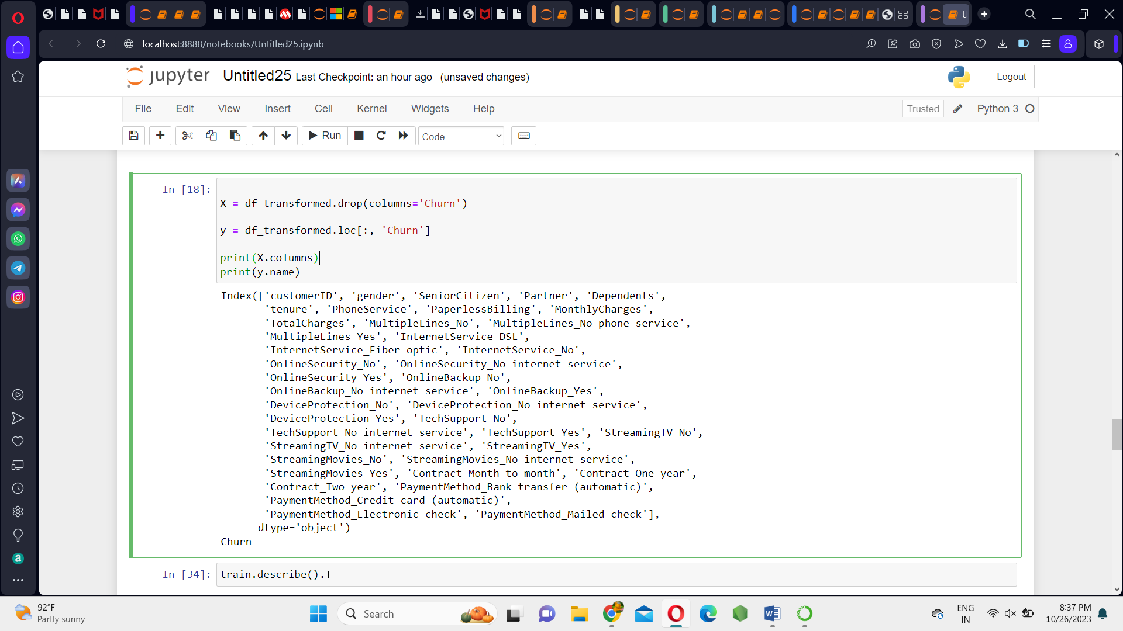

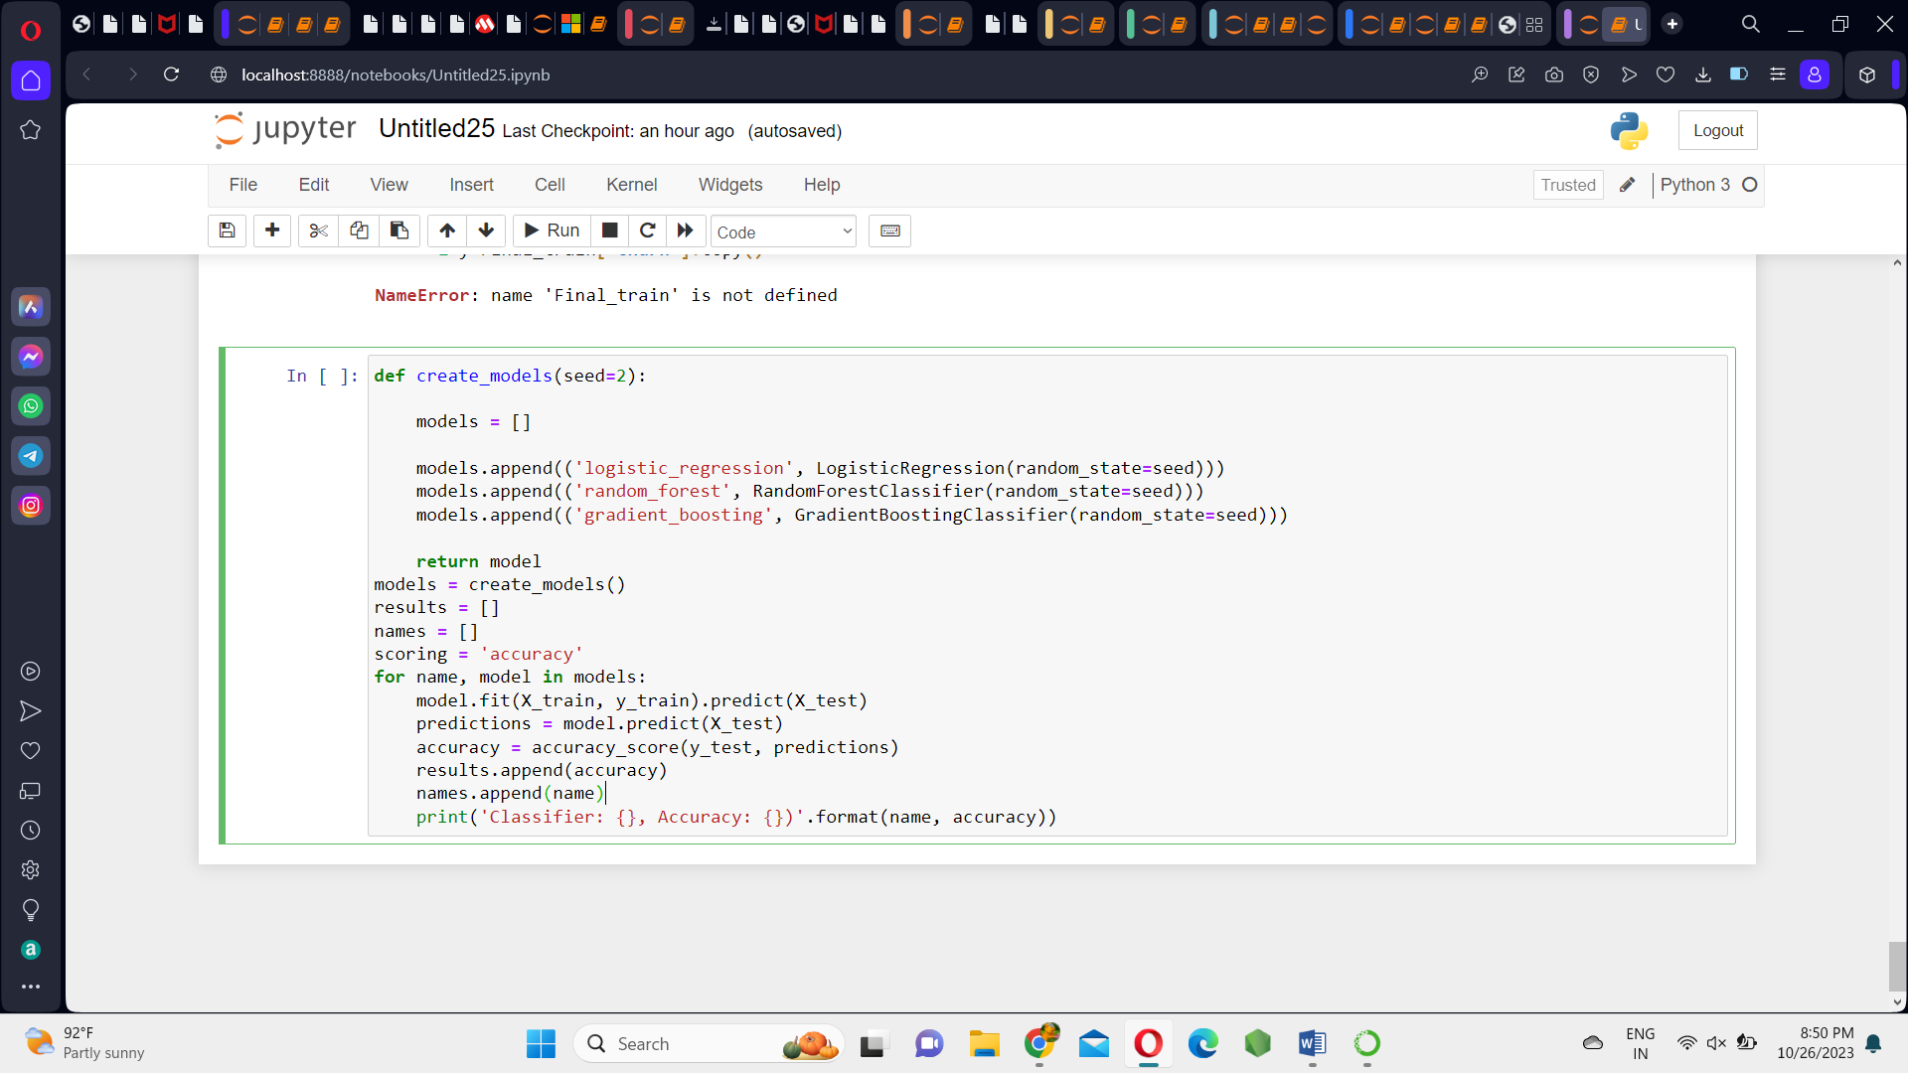

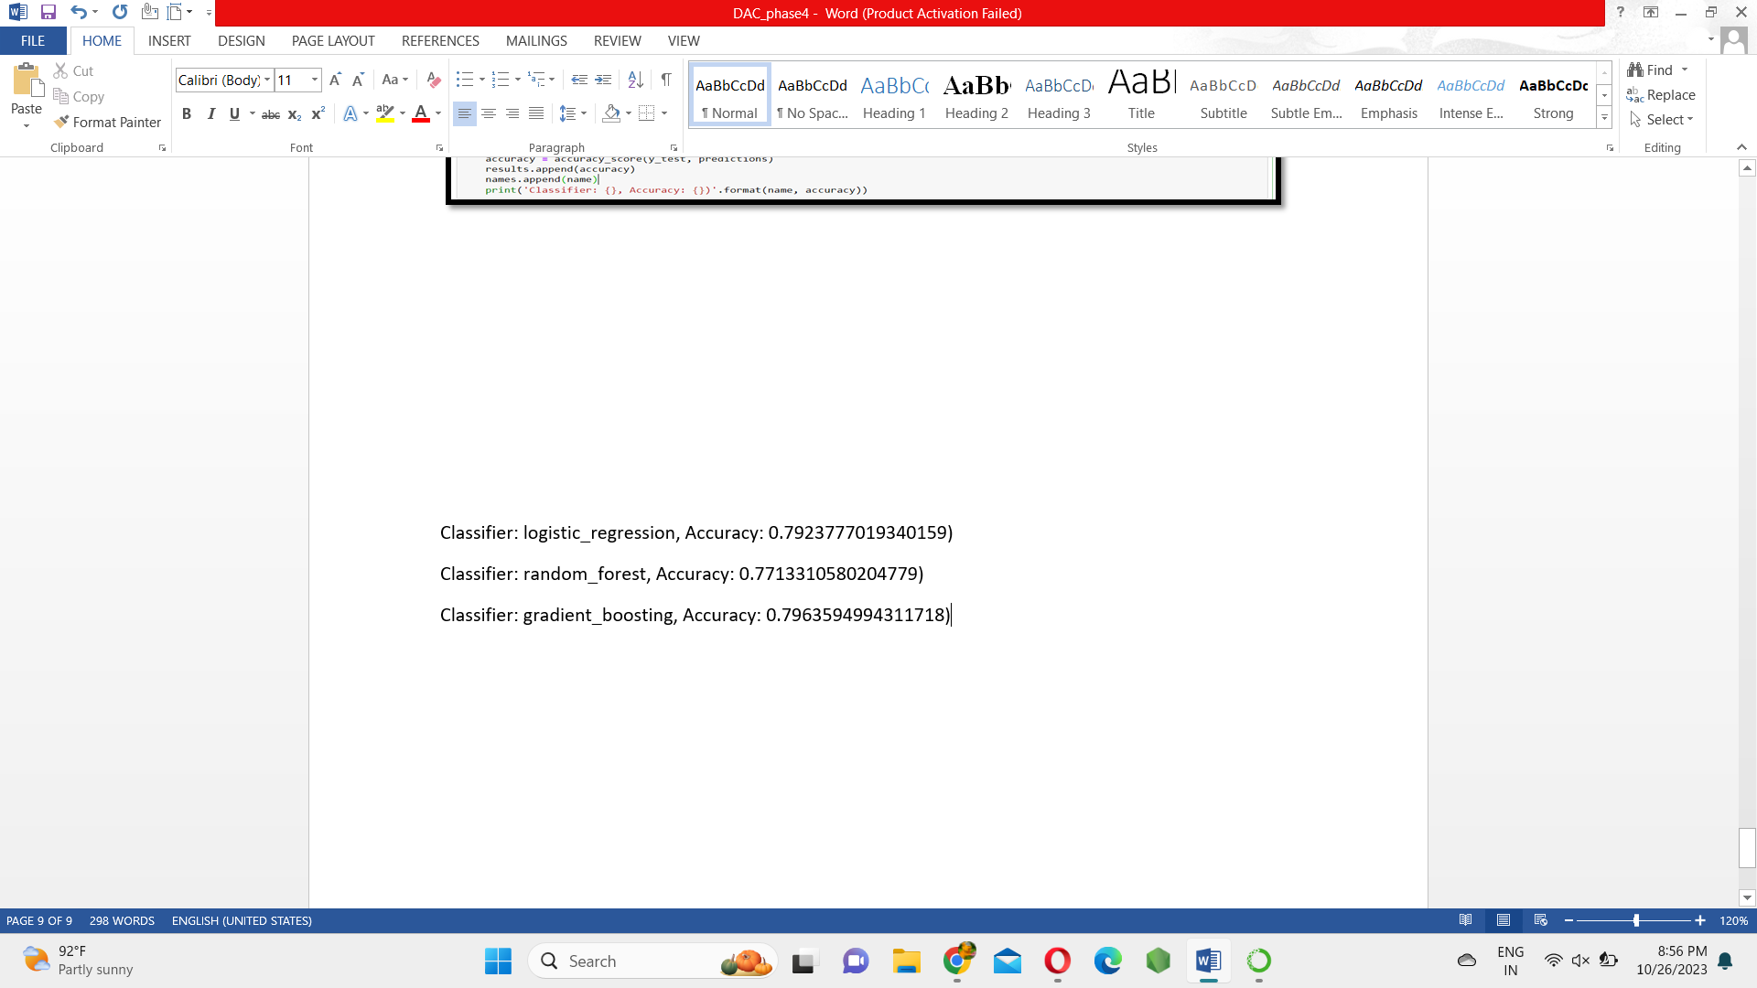

**XGBoost**

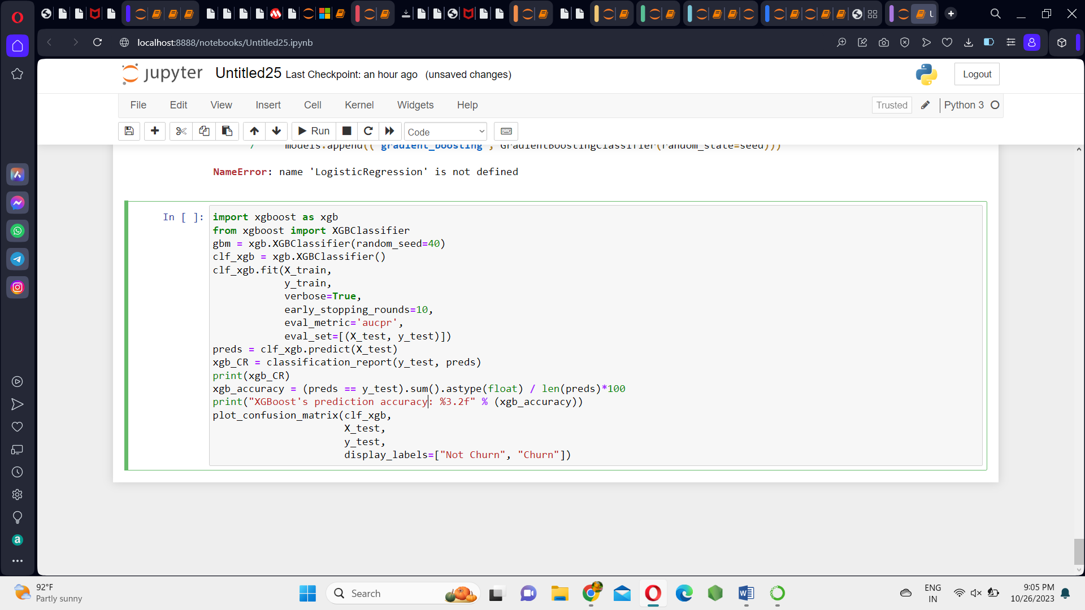

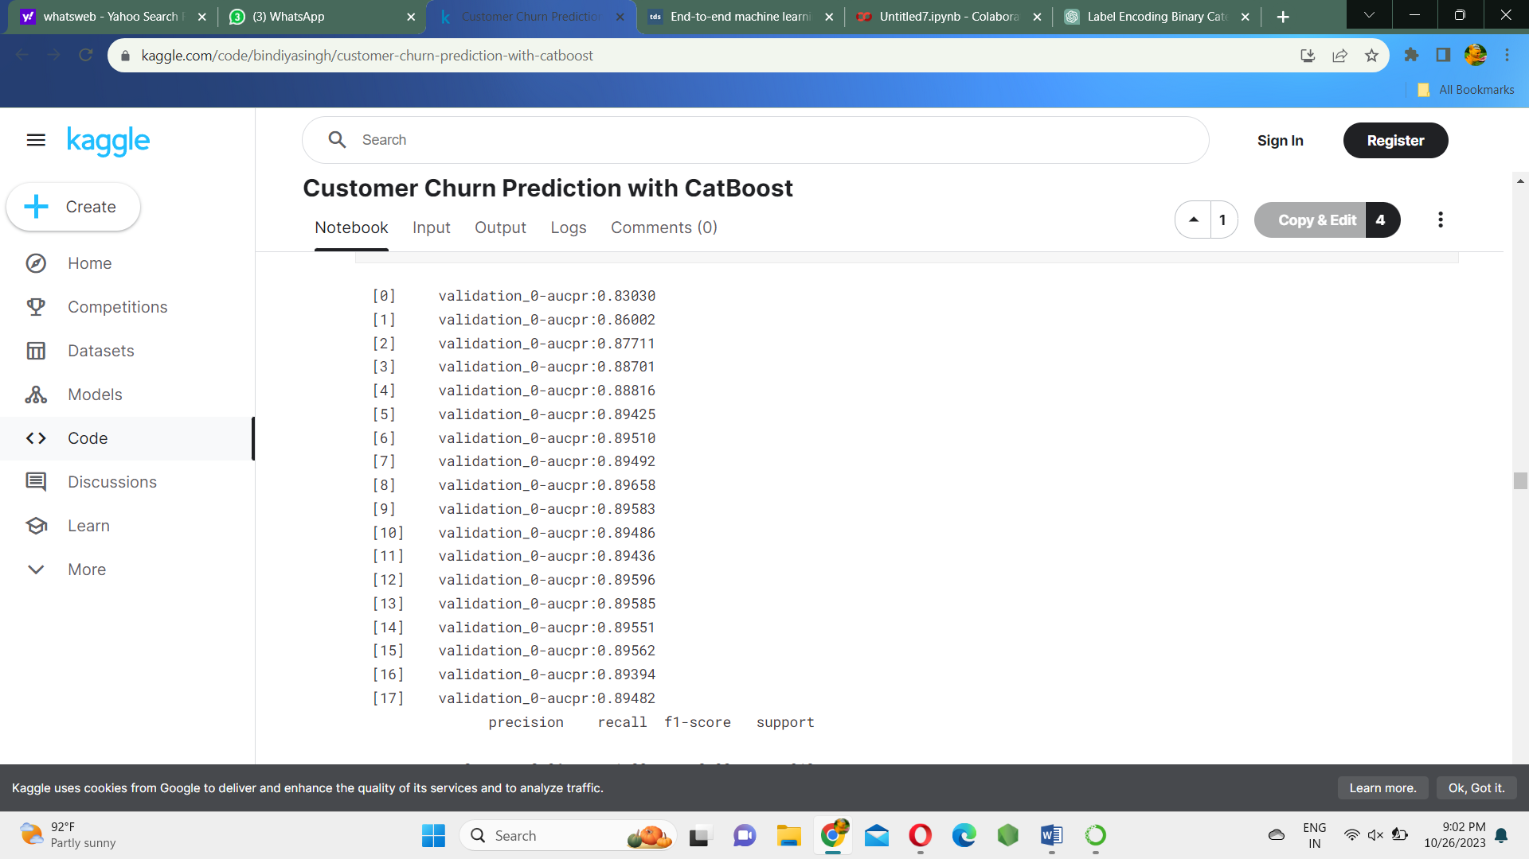

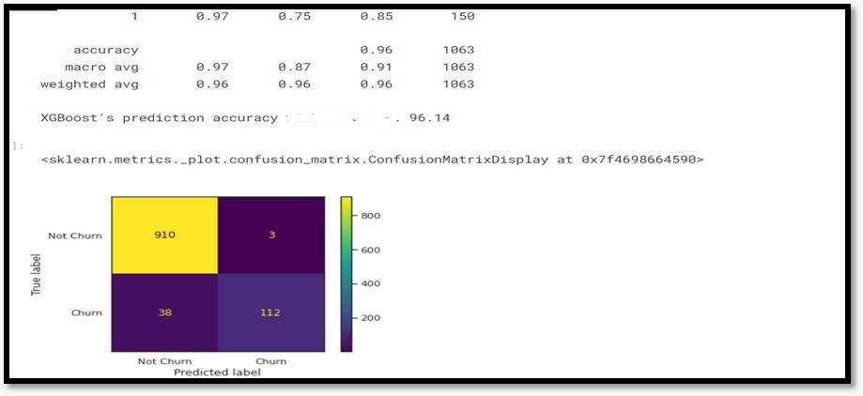

**CatBoost**

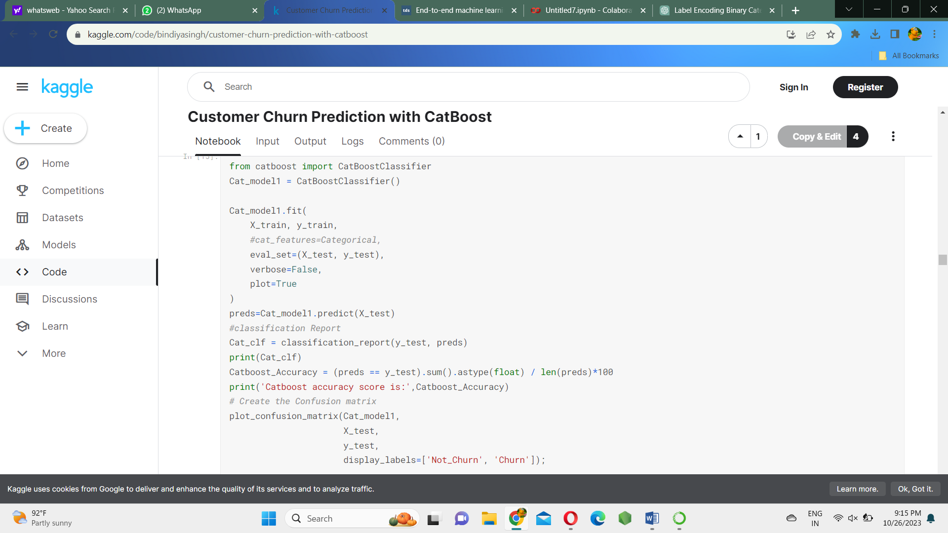

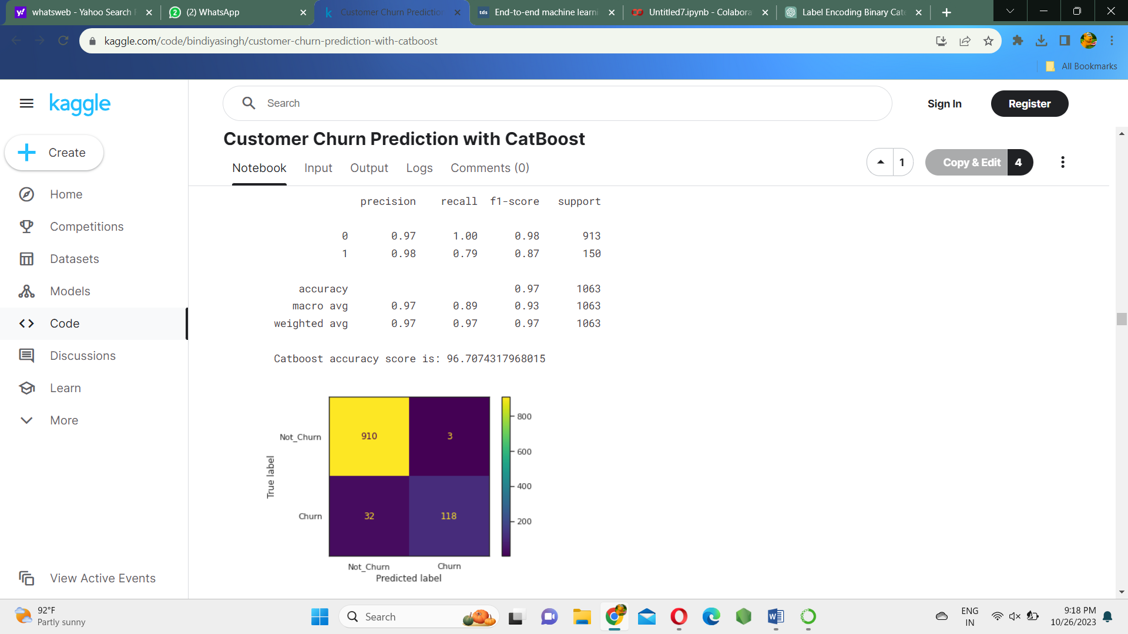

|  |  |
| --- | --- |
| **TEAM ID** | **PROJ_224694_TEAM_2** |
| **TEAM MEMBERS** | **S.RAJARAJESHWARI**  **SANDHIYA.S**  **PRIYADHARSHINI .S**  **KOKILA.U**  **VISHNUPRIYA P** |
| **NAME** | **VISHNUPRIYA P** |
| **REGISTER NUMBER** | **420421205025** |